Laura Robinson

“Picture the Preamble”

IDT 3600-501

LVKCKHAM@memphis.edu

3/29/10
Preamble Phrases | Picture | Why the picture was chosen
We the People of the United States | 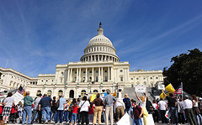 http://www.flickr.com/photos/  28722563@N05/ | I chose this picture because it shows a group of different nationalities standing up for what they believe in. People of the United States are of all nationalities and beliefs; I thought this picture showed that well.
in Order to form a more perfect Union | http://www.flickr.com/photos/spang/ | I chose this picture because it shows a small group holding up a sign saying “The people United will never be divided”. I thought the picture had great meaning of how united Americans are.
establish Justice | http://www.flickr.com/photos/vitualis/ | This picture with the gavel and law books gives an example of how Justice is served in our country. I thought it went well with this Preamble phrase.
Insure domestic Tranquility | 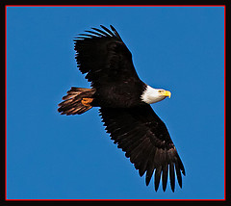  http://www.flickr.com/photos/evanspellman/ | I chose the picture of the flying eagle because not only does the eagle represent our country, but also because I feel that the picture represents peace well.
provide for the common defense | 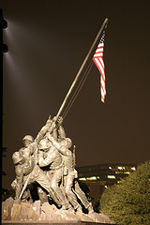  http://www.flickr.com/photos/bigmikesndtech/ | I chose the memorial of Iwo Jima because it shows how from past to present we always have countrymen protecting the United States.
promote the general Welfare | 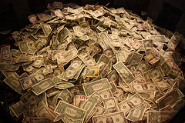  http://www.flickr.com/photos/aresauburnphotos/ | I chose the picture of money because it shows the opportunities Americans have. Anyone has a chance in the United States to make something of themselves.
and secure the Blessings of Liberty to ourselves and our Posterity | 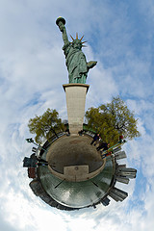  http://www.flickr.com/photos/gadl/ | I chose this picture because it has the Statue of Liberty, which is a great symbol of our country. I thought the fact that the picture included the surroundings in a globe was a great effect to show how Americans care for not only our liberty, but also the liberty of others.
do ordain and establish this Constitution for the United States of America | 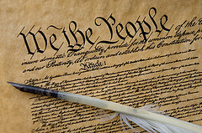  http://www.flickr.com/photos/rosieobeirne/ | I chose this picture because I felt it was only right to end with the picture of the Constitution.

Reflection

The Preamble to the United States Constitution has great meaning to me. Just the Preamble alone has a lot of meaning, explaining what the people of the United States stand for. I am very proud to be an American and even more proud that I have such a strong and secure government.
Giving such an illustrated explanation gave me great pride; it is a great feeling to illustrate the different parts of the Preamble. Being able to understand the Preamble and the Constitution is very important to me, so this assignment is a great one to use in the classroom. Allowing students to pick apart such an important document and make it their own by adding pictures lets the students understand it better as well as gives the student pride in their country.

